Bern’s Park Fund Raiser

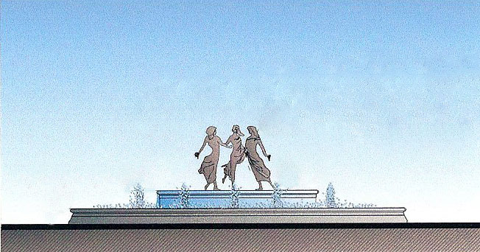

YES! I would like to purchase brick(s) One Brick $200. Additional Bricks $125 each.

NAME {PLEASE PRINT} SIGNATURE:

ADDRESS:

CITY: STATE: ZIP;

TELEPHONE: EMAIL:

Please inscribe the following on my brick(s): 1

YOUR NAME HERE

15 CHARACTERS/LINE

If you are purchasing more than one brick, write the additional lines on the reverse side of this order form. (15 characters per line). Your contribution to the bricks program above the fair market value cost of $50 for each inscribed brick is tax deductible as a charitable contribution to the Hyde Park Community Fund Inc. for the Bern's Park Project. A receipt for your contribution will be sent to you by the HPCF.

If you have any questions, please call Barbara Deakin, at 813-431-2811. And thank you for your support

